Notes to the presentation
Interventricular septum
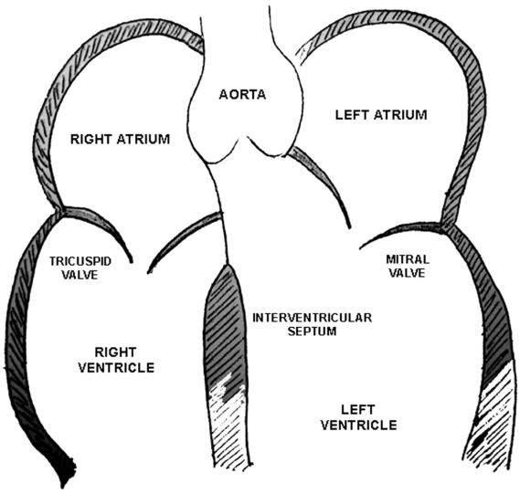
The membranous part of the interventricular septum has a special location. It is not only between the two ventricles, but it also has a tiny part between the left ventricle and the right atrium right below the aortic valve.
Notice on the picture the relationship of the atrioventricular valves: the mitral valve is located a bit above the tricuspid.
How to find the membranous part of the interventricular septum?
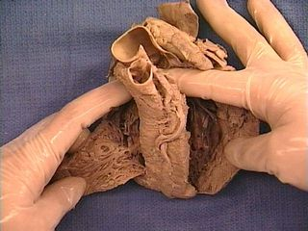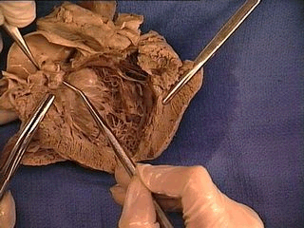
Notes on the coarctation of aorta
Coarctation of aorta: narrowing in the place of insertion of the ductus arteriosus (distal to the insertion of the left subclavian artery).
During the formation of the aorta, muscle tissue from the ductus arteriosus can be incorporated in the aortic wall. The coarctation forms when the DA and this ectopic muscle tissue contract.
The coarctation can be ductal, preductal or postductal according to the relationship to the DA.
Clinically it is recognizable by its very characteristic heart murmur and by the difference of arterial pressure in the higher and lower extremities.
The cardiothoracic index
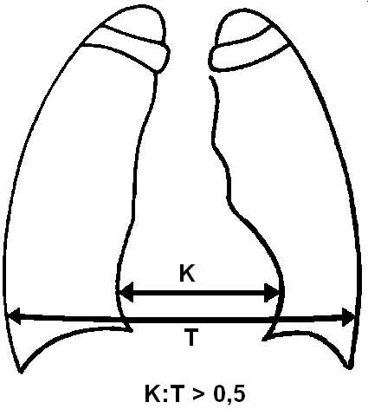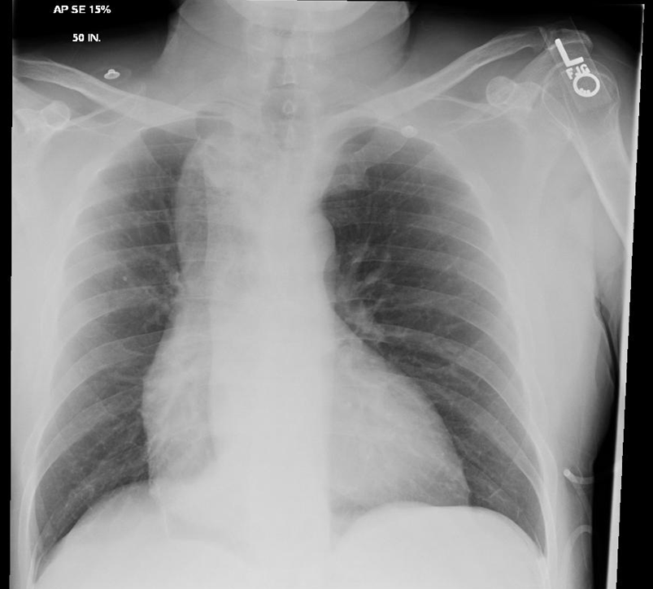
On the x-ray on the right, the cardiothoracic index is obviously a lot higher than 0,5, meaning a cardiac hypertrophy (usually due to hypertension)
Coronarography:
These are the same I gave you in the .ppt, but this time with captions (taken from Sobotta’s):
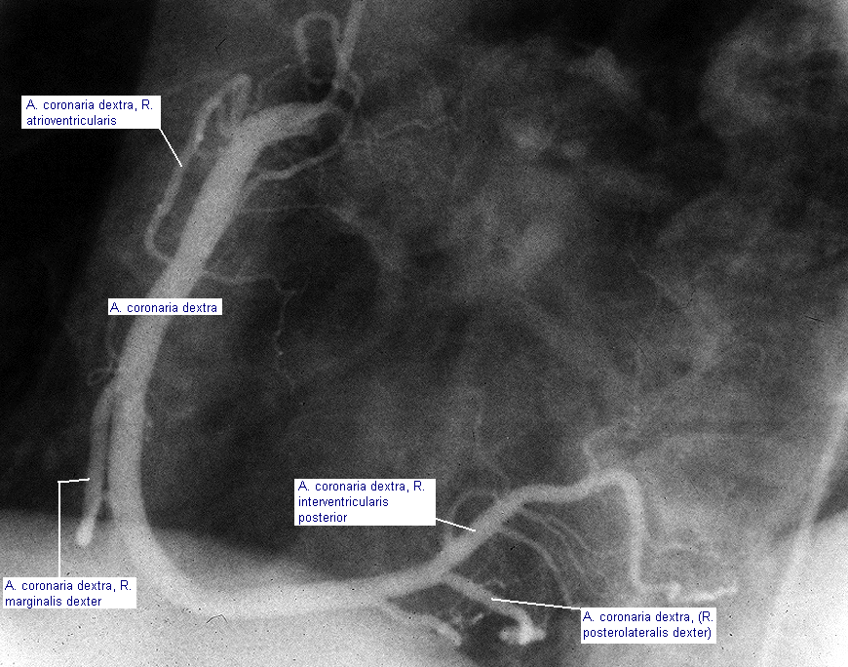
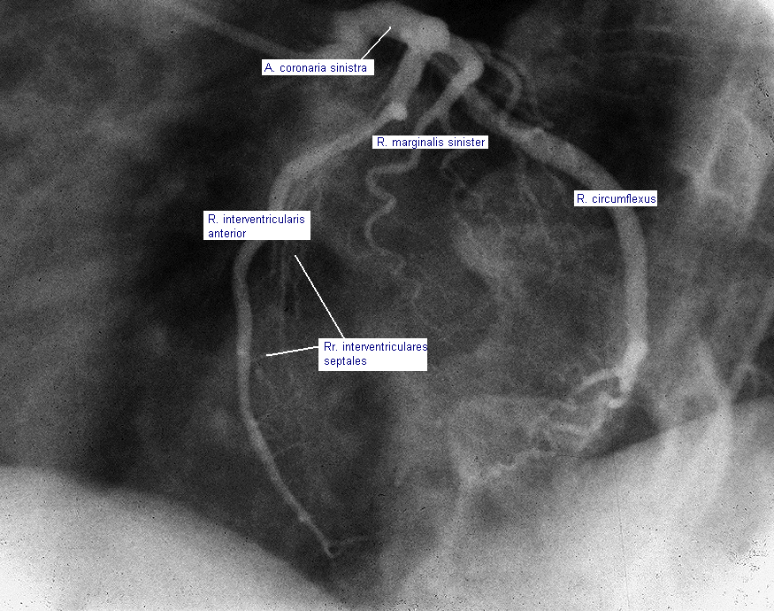

Where does the word „mitral“ come from?
The mitral valve got its name due to its seeming resemblance to a mitre.
Wikipedia says:
The mitre, also spelled miter, is a type of headgear now known as the traditional, ceremonial head-dress of bishops and certain abbots in the Roman Catholic Church, as well as in the Anglican Communion, some Lutheran churches, and also bishops and certain other clergy in the Eastern Orthodox churches, Eastern Catholic Churches and the Oriental Orthodox Churches.

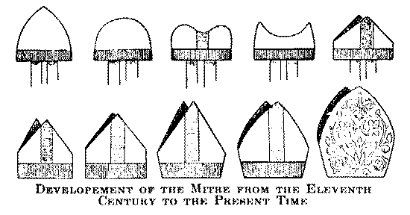

End-arterial systems
End arteries, also known as terminal arteries are arteries that are the only blood supply for a portion of an organ, meaning there are no anastomoses in that organ.
In some organs, anastomoses do exist, but they are not sufficient if an occlusion should appear. These arteries are called functional end arteries.
End arteries: retina
Functional end arteries: heart, brain, kidney.

